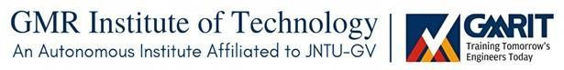

A Mini Project report submitted in partial fulfillment of the requirement for the Award of degree

BACHELOR OF TECHNOLOGY
in
COMPUTER SCIENCE AND ENGINEERING

Submitted By
S.Sudheer(24345A0501)
B.Rama devi(23341A0515)
Ch.Bhavana(23341A0547)
Ch.Roshini(23341A0543)
G.Tulasi(24345A0508)

Under the guidance of
Dr D.Sowjanya
Assistant Professor
GMR Institute of Technology

GMR Institute of Technology
An Autonomous Institute Affiliated to JNTU-GV, Vizianagaram
(Accredited by NBA, NAAC with ‘A’ Grade & ISO 9001:2015 Certified Institution)
GMR Nagar, Rajam – 532127 Andhra Pradesh, India
April 2026



DEPARTMENT OF COMPUTER SCIENCE AND ENGINEERING
CERTIFICATE

This is to certify that term paper report titled “Personalized placement training system” submitted by S.Sudheer, B.Rama Devi, Ch.Bhavana, Ch.Roshini, G.Tulasi bearing Reg.No: 24345A0501, 23341A0515, 23341A0547, 23341A0543, 24341A05084 has been carried out in partial fulfillment for the award of Bachelor of Technology in COMPUTER SCIENCE AND ENGINEERING of GMRIT, Rajam affiliated to JNTUGV, Vizianagaram is a record of bonafide work carried out by them under my guidance & supervision. The results embodied in this report have not been submitted to any other University or Institute for the award of any degree.

Signature of the Supervisor Signature of the H.O.D

Dr D.Sowjanya Dr.A.Venkata Ramana

Assistant Professor Professor,HOD-CSE,
GMRIT, Rajam. GMRIT, Rajam.

The report is submitted for the viva-voice examination held on ………………..

Signature of Internal Examiner Signature of External Examiner

 | INDEX
CONTENTS |  | PAGE NO
CERTIFICATE |  | i
ACKNOWLEDGEMENT |  | iii
ABSTRACT |  | iv
Chapter 1. INTRODUCTION |  | 1
Chapter 2. LITERATURE SURVEY |  | 4
Chapter 3. DESIGN |  | 36
Chapter 4. METHODOLOGY |  | 38
Chapter 5. CASE STUDIES |  | 45
Chapter 6. RESULTS & DISCUSSION |  | 49
Chapter 7. CONCLUSION |  | 51
REFERENCES |  | 52

ACKNOWLEDGEMENT

It gives me an immense pleasure to express deep sense of gratitude to our guide, Dr D.Sowjanya
Assistant Professor, Department of Computer Science and Engineering of whole hearted and invaluable guidance throughout the report. Without his/her sustained and sincere effort, this report would not have taken this shape. He/she encouraged and helped me to overcome various difficulties that I have faced at various stages of my report.
We would like to sincerely thank our Head of the Department, Dr. A V Ramana, for providing all the necessary facilities that led to the successful completion of our project work.
We would like to take this opportunity to thank our beloved Principal, Dr. C. L. V. R. S. V Prasad, for providing a great support to us in completing our project and for giving us the opportunity of doing the project work.
We would like to thank all the faculty members of the Department of Computer Science and Engineering for their direct or indirect support and also all the lab technicians for their valuable suggestions and providing excellent opportunities in completion of this report.
Finally, we would like to thank all of our friends and family members for their continuous help and encouragement.

S.Sudheer (24345A0501) B.Rama devi (23341A0515) Ch.Bhavana (23341A0547) Ch.Roshini (23341A0543) G.Tulasi (24341A0508)

ABSTRACT
The rapid evolution of the job market and increasing competition among graduates have highlighted a significant gap between academic learning and industry requirements. Traditional placement systems primarily rely on academic performance and manual evaluation processes, which often fail to provide personalized guidance and accurate prediction of student employability. To address these challenges, this project proposes an Personalized Placement Assistance System that leverages advanced machine learning, deep learning, and natural language processing techniques to enhance student placement outcomes.
The proposed system integrates multiple intelligent modules, including placement prediction, career recommendation, skill gap analysis, and AI-driven interview evaluation. Machine learning algorithms such as Random Forest, Naïve Bayes, and Gradient Boosting are utilized to predict placement probability based on academic performance, technical skills, and behavioral attributes. In addition, deep learning models like BiLSTM and semantic models such as Sentence-BERT (SBERT) are employed to improve recommendation accuracy by analyzing complex relationships between student profiles and job roles.
The system also incorporates Natural Language Processing (NLP) and speech analysis techniques to evaluate interview performance, focusing on communication clarity, confidence, and response quality. Furthermore, reinforcement learning and knowledge graph-based approaches are used to generate adaptive and personalized career pathways. By continuously analyzing user performance and feedback, the system provides real-time recommendations and improvement strategies.
Experimental observations from existing research indicate that such AI-driven systems can achieve high prediction accuracy ranging from 76% to 99.7%, significantly improving decision-making reliability. The proposed platform aims to reduce manual effort, enhance transparency, and provide data-driven insights for both students and placement authorities.
In conclusion, the system offers a comprehensive and intelligent solution to bridge the gap between academic preparation and industry expectations, ultimately improving student employability and placement success rates.

KEYWORDS: Artificial Intelligence (AI), Machine Learning (ML), Placement Prediction, Career Recommendation System, Deep Learning.

1.INTRODUCTION
Personalized placement assistance system

In today’s rapidly evolving and highly competitive job market, securing employment requires more than just academic excellence. Employers increasingly seek candidates who possess a balanced combination of technical expertise, problem-solving abilities, communication skills, and adaptability. However, traditional educational systems primarily focus on theoretical knowledge, often leaving students underprepared for real-world industry expectations. This mismatch between academic preparation and industry requirements has led to a growing need for intelligent systems that can guide students effectively toward successful career paths.

Conventional placement processes in educational institutions rely heavily on manual evaluation methods such as academic scores, aptitude tests, and basic interview assessments. While these methods provide a general overview of student capabilities, they lack personalization and fail to capture the complete profile of a candidate. Moreover, they do not provide actionable insights or continuous feedback to help students improve their skills. As a result, many students remain unaware of their strengths, weaknesses, and suitable career opportunities, which ultimately affects their placement success.

With the advancement of Artificial Intelligence (AI) and Machine Learning (ML), it has become possible to develop intelligent systems capable of analyzing large volumes of student data and generating meaningful insights. These technologies enable the prediction of placement outcomes, identification of skill gaps, and recommendation of suitable job roles based on individual profiles. Machine learning algorithms such as Random Forest, Naïve Bayes, and Gradient Boosting can process multi-dimensional data including academic performance, technical skills, internships, and behavioral attributes to accurately estimate placement probability.

In addition to predictive analytics, modern AI systems incorporate Natural Language Processing (NLP) and speech analysis techniques to evaluate communication skills and interview performance. These technologies allow automated assessment of candidate responses, including clarity, relevance, confidence, and structure. Such capabilities provide students with real-time feedback and help them improve their performance in interviews, which is a critical component of the placement process.

Furthermore, advanced models such as Sentence-BERT (SBERT) and Reinforcement Learning enable personalized career recommendations by understanding semantic relationships between skills, interests, and job roles. Knowledge graph-based approaches further enhance this process by mapping connections between academic domains, industry requirements, and career opportunities. This combination of technologies allows the system to provide adaptive and data-driven guidance tailored to each individual student.

The proposed Personalized Placement Assistance System aims to address the limitations of traditional placement methods by integrating multiple intelligent components into a unified platform. The system not only predicts placement outcomes but also provides personalized recommendations, identifies skill gaps, and offers structured improvement pathways. By continuously analyzing student performance and feedback, the system adapts dynamically to deliver more accurate and relevant suggestions over time.

Another key advantage of the proposed system is its ability to reduce manual effort for placement officers and educators. By automating tasks such as candidate evaluation, job matching, and performance tracking, the system improves efficiency and ensures consistency in decision-making. Additionally, the platform provides a centralized dashboard where students can monitor their progress, track improvements, and access personalized recommendations.

1.1 OVERVIEW OF THE PROJECT

The project is a web/mobile-based application designed to enhance student employability through an intelligent and personalized placement assistance system. The platform integrates advanced technologies such as Artificial Intelligence (AI), Machine Learning (ML), and Natural Language Processing (NLP) to provide data-driven career guidance and placement support.

The system is structured into multiple modules, including placement prediction, career recommendation, skill assessment, and interview evaluation. Students can create profiles, input their academic details, technical skills, and interests, and receive personalized insights regarding their placement readiness.

Users can explore recommended career paths, practice aptitude and coding questions, and participate in AI-driven mock interviews. Based on their performance, the system analyzes strengths and weaknesses, identifies skill gaps, and provides adaptive learning suggestions.

The platform also includes a user-friendly dashboard where students can track their placement probability, skill improvement progress, and recommended learning paths. Additional features such as performance analytics, feedback reports, and career ranking systems help users make informed decisions about their future.

1.2 PROBLEM STATEMENT

In the current education system, there exists a significant gap between academic learning and industry expectations. Traditional placement processes rely on manual evaluation, academic scores, and limited assessments, which do not provide a complete understanding of a student’s capabilities.

Students often lack awareness of their strengths, weaknesses, and suitable career paths, resulting in poor preparation and lower placement success rates. Additionally, existing systems do not offer personalized guidance, real-time feedback, or adaptive learning mechanisms.

There is a strong need for an intelligent and automated placement assistance system that can accurately predict placement outcomes, recommend suitable job roles, and guide students in improving their technical and soft skills through data-driven insights.

1.3 OBJECTIVES OF THE PROJECT

To predict student placement probability using machine learning algorithms

To recommend suitable career paths based on skills and interests

To evaluate interview performance using NLP and speech analysis

To identify technical and soft skill gaps through data analysis

To provide personalized learning and improvement recommendations

To automate the placement preparation process

To enhance student employability through intelligent guidance

1.4 SCOPE OF THE PROJECT

This project is primarily focused on improving placement preparation and career guidance for students using AI-based technologies. The system can be deployed as a web or mobile application, making it easily accessible to students anytime and anywhere.

The platform can be extended to support:

Integration with job portals and recruitment systems

Advanced real-time analytics and performance tracking

Multi-language support for diverse users

Expansion to other domains such as higher education guidance and skill development platforms

The system can also be implemented in colleges, universities, and training institutes to streamline placement processes and provide structured, data-driven career support.

2.LITERATURE SURVEY

Reference 1
[1] Author(s). (2024). Personalized process-type learning path recommendation based on process mining and deep knowledge tracing. Journal Name.
Objectives:
- To develop a personalized learning path recommendation system
- To integrate process mining with Deep Knowledge Tracing (DKT)
- To analyze student learning behavior and sequences
- To improve adaptive learning and engagement
- To provide real-time intervention strategies
Advantages:
- Enhances personalized learning pathways
- Improves student engagement and retention
- Supports adaptive assessment systems
Limitations:
- Requires continuous behavioral data tracking
- High computational complexity
- Privacy concerns due to data monitoring

Reference 2
[2] Author(s). (2025). Job Recommendation System using BiLSTM with Attention Mechanism. IEEE Access.
Objectives:
- To develop a deep learning-based job recommendation system
- To analyze sequential career and skill data
- To improve job-role matching accuracy
- To capture long-term dependencies in career paths
- To enhance recommendation interpretability
Advantages:
- Handles sequential data effectively
- Improves recommendation accuracy
- Reduces cold-start problem
Limitations:
- Requires large datasets
- High computational cost
- Risk of overfitting

Reference 3
[3] Author(s). (2025). PathPilot: AI-Based Placement Prediction System. Journal Name.
Objectives:
- To predict placement probability using AI models
- To analyze academic and skill-based data
- To provide career recommendations
- To monitor student performance
- To improve placement outcomes
Advantages:
- High prediction accuracy
- Personalized recommendations
- Real-time skill tracking
Limitations:
- Data quality dependency
- Requires frequent updates
- Privacy concerns

Reference 4
[4] Author(s). (2024). AI-Based Competency Recommendation using Gradient Boosting. Journal Name.
Objectives:
- To predict student competency levels
- To use Gradient Boosting for analysis
- To improve skill mapping accuracy
- To support personalized learning
- To optimize model performance
Advantages:
- High accuracy
- Handles complex datasets
- Supports targeted skill improvement
Limitations:
- Requires structured data
- High training time
- Limited interpretability

Reference 5
[5] Author(s). (2025). AI Job Interview Preparation Portal using NLP. IRJMETS.
Objectives:
- To develop an AI-based interview simulation system
- To analyze communication and response quality
- To evaluate interview performance
- To provide automated feedback
- To improve soft skills
Advantages:
- Realistic interview simulation
- Improves communication skills
- Provides personalized feedback
Limitations:
- Limited emotional understanding
- Depends on speech recognition
- Privacy concerns

Reference 6
[6] Author(s). (2025). Adaptive AI Framework for Placement Preparation. IJSART.
Objectives:
- To develop a complete placement preparation system
- To integrate aptitude, coding, and communication modules
- To provide real-time feedback
- To improve overall student performance
- To enhance employability
Advantages:
- Comprehensive system
- Improves both technical and soft skills
- Provides real-time analytics
Limitations:
- Requires advanced infrastructure
- High computational requirements
- Accuracy varies with environment

Reference 7
[7] Author(s). (2023). Placement Hive – AI-Based Placement Portal. Journal Name.
Objectives:
- To automate recruitment processes
- To use NLP for resume screening
- To improve candidate-job matching
- To reduce manual effort
- To enhance recruitment efficiency
Advantages:
- Reduces workload
- Improves screening accuracy
- Faster recruitment process
Limitations:
- Data dependency
- Risk of bias
- Requires continuous updates

Reference 8
[8] Author(s). (2023). Student Placement Prediction using Classification Techniques. IJARSCT.
Objectives:
- To compare multiple ML algorithms
- To predict placement outcomes
- To analyze academic performance
- To identify best-performing model
- To improve prediction accuracy
Advantages:
- High accuracy
- Comparative analysis
- Early prediction
Limitations:
- Risk of overfitting
- Limited real-world applicability
- Complex model interpretation

Reference 9
[9] Author(s). (2022). Placement Prediction using ML Algorithms. IJRASET.
Objectives:
- To predict placement using ML models
- To analyze academic and skill data
- To improve prediction accuracy
- To optimize feature selection
- To reduce overfitting
Advantages:
- Effective ensemble learning
- Improved accuracy
- Better feature selection
Limitations:
- Limited soft skill analysis
- Dataset dependency
- Needs continuous updates

Reference 10
[10] Author(s). (2024). Soft Skills Assessment using ML and Serious Games. Journal Name.
Objectives:
- To assess soft skills using ML
- To analyze behavioral patterns
- To evaluate communication and teamwork
- To improve employability
- To provide skill-based classification
Advantages:
- Captures non-technical skills
- Improves student profiling
- Enhances employability
Limitations:
- Subjective evaluation
- Privacy concerns
- Requires complex setup

Reference 11
[11] Author(s). (2024). Ontology-Based Competency Recommender System. Journal Name.
Objectives:
- To develop ontology-based recommendation system
- To map skills with job roles
- To improve semantic matching
- To enhance personalization
- To support adaptive learning
Advantages:
- Structured skill mapping
- Better recommendation accuracy
- Supports dynamic adaptation
Limitations:
- Complex design
- Requires domain expertise
- Scalability issues

Reference 12
[12] Author(s). (2023). Student Performance Prediction using SVM and Naïve Bayes. Journal Name.
Objectives:
- To predict student performance
- To use SVM and Naïve Bayes
- To analyze academic indicators
- To classify performance levels
- To support early intervention
Advantages:
- Strong classification performance
- Reliable prediction
- Supports academic planning
Limitations:
- Focuses only on academics
- Limited real-world factors
- Parameter tuning required

Reference 13
[13] Author(s). (2025). Multi-Factor ML Framework with Explainable AI. MethodsX.
Objectives:
- To develop multi-factor prediction model
- To integrate academic and behavioral data
- To improve prediction accuracy
- To apply Explainable AI techniques
- To enhance transparency
Advantages:
- Holistic analysis
- Improved interpretability
- Better decision-making
Limitations:
- Requires large datasets
- High computational cost
- Privacy concerns

Reference 14
[14] Author(s). (2024). AI-Based Recommender Systems Survey. IEEE Access.
Objectives:
- To review modern recommender systems
- To analyze deep learning approaches
- To compare recommendation techniques
- To study personalization methods
- To identify future trends
Advantages:
- Comprehensive overview
- Useful for system design
- Highlights best practices
Limitations:
- No practical implementation
- Theoretical analysis
- Lacks real-time evaluation

Reference 15
[15] Author(s). (2024). Process Mining-Based Adaptive Learning System. Conference Paper.
Objectives:
- To analyze learning behavior using process mining
- To develop adaptive learning paths
- To improve learning outcomes
- To track student interaction
- To personalize recommendations
Advantages:
- Dynamic learning adaptation
- Improves engagement
- Data-driven insights
Limitations:
- High data dependency
- Computational complexity
- Privacy issues

Reference 16
[16] Author(s). (2025). Multi-Source Intelligent Tutoring System. IEEE Access.
Objectives:
- To develop multi-source student model
- To integrate data from multiple stakeholders
- To improve personalization
- To track performance continuously
- To enhance learning outcomes
Advantages:
- Holistic student profiling
- Improved personalization
- Better performance tracking
Limitations:
- Complex implementation
- Data inconsistency issues
- Privacy concerns

Graphical representation with literature Survey
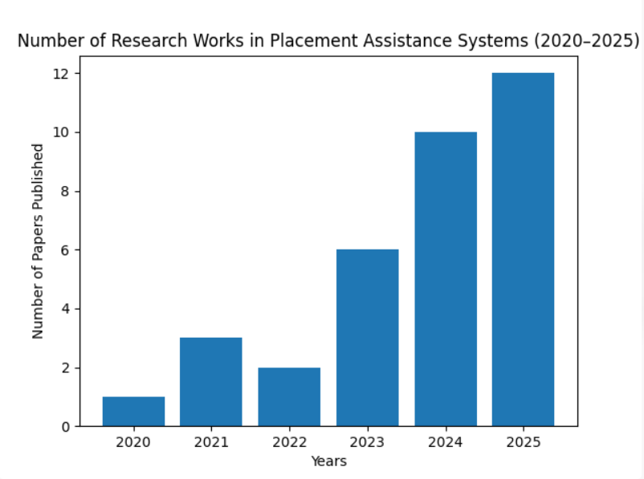

3. REQUIREMENT ANALYSIS

3.1 REVIEW OF THE RELATED WORK / EXISTING SYSTEM
- Traditional placement systems rely on manual evaluation methods
- Focus mainly on academic performance (CGPA, marks)
- Lack of personalized career guidance
- No proper skill gap identification
- Limited interview preparation support
- No integration of AI/ML for prediction and recommendation
- Lack of real-time feedback and performance tracking
- Minimal support for soft skills and communication analysis

3.2 PROPOSED SYSTEM
The proposed system is an Personalized Placement Assistance System that:
- Provides placement prediction using Machine Learning algorithms
- Recommends suitable job roles based on skills and interests
- Identifies technical and soft skill gaps
- Conducts AI-driven mock interviews using NLP and speech analysis
- Provides personalized learning and improvement suggestions
- Displays performance analytics and progress tracking dashboard
- Offers adaptive recommendations using AI models
- Reduces manual effort through intelligent automation

3.3 FUNCTIONAL AND NON-FUNCTIONAL REQUIREMENTS

Functional Requirements
- User registration and login
- Profile creation (academic, skills, interests)
- Placement prediction using ML models
- Career recommendation system
- Skill gap analysis
- Mock interview module (AI-based evaluation)
- Performance tracking dashboard
- Feedback and improvement suggestions

Non-Functional Requirements
- User-friendly interface
- Fast system response time
- Scalability for multiple users
- High reliability and availability
- Secure data handling and privacy protection
- Efficient performance of ML models
- Cross-platform compatibility (web & mobile)

3.4 HARDWARE AND SOFTWARE REQUIREMENTS

Hardware Requirements
- Computer/Laptop (for development and testing)
- Smartphone (for mobile application testing)
- Stable internet connection

Software Requirements

Frontend (Web Application)
- React (with Vite for fast development and optimization)

Mobile Application
- React Native
- Expo Go (for testing mobile app)

Backend

Node.js + Express.js

Database
- MongoDB Atlas (cloud-based NoSQL database)

Deployment
- Render (for hosting backend services)

Development Tools
- VS Code
- Git & GitHub
- Web Browser (Google Chrome)

4.System Analysis and Design

4.1 SYSTEM OVERVIEW
The proposed system is an Personalized Placement Assistance System consisting of a web/mobile application for students and a web-based dashboard for administrators (placement officers).

Students can:
- Login to the system
- Create and update their profile (academic details, skills, interests)
- View placement prediction results
- Get personalized career recommendations
- Practice aptitude, coding, and technical questions
- Participate in AI-driven mock interviews
- Receive feedback on communication and performance
- Track progress through dashboard and analytics

Admin can:
- Manage student data and profiles
- Monitor placement predictions and reports
- Analyze student performance and skill gaps
- Manage job roles and recommendation criteria
- View overall placement statistics and analytics
The system ensures intelligent decision-making, personalized learning, and performance tracking to improve student employability.

4.2 FEASIBILITY STUDY

Technical Feasibility
The system can be implemented using modern technologies such as:
- Mobile App: React Native + Expo Go
- Web App: React + Vite
- Backend: Node.js + Express.js
- Database: MongoDB Atlas
- AI Models: Machine Learning (Random Forest, Gradient Boosting), NLP models

Economic Feasibility
- Low development cost using open-source technologies
- Reduces manual effort in placement processes
- Minimizes administrative and operational costs
- Scalable for future expansion without high investment

Operational Feasibility
- User-friendly interface for students and administrators
- Requires minimal training to operate
- Easily adaptable in colleges and training institutions
- Provides automated and efficient placement assistance

4.3 SYSTEM ARCHITECTURE
The system follows a Client-Server Architecture integrated with AI components:

Client Side:
- Mobile Application (Student Interface)
- Web Application (Admin Dashboard)

Server Side:
- Handles user authentication and authorization
- Processes requests and responses
- Runs machine learning models for prediction and recommendation
- Performs NLP-based interview analysis

Database:
- Stores student profiles, skills, and academic data
- Stores prediction results and recommendations
- Maintains interview performance records and analytics

4.4 DATA FLOW DIAGRAM (DFD)

Level 0 DFD (Overview)
- Input: Student profile data, skills, interview responses
- Process: Data processing, ML prediction, recommendation, evaluation
- Output: Placement probability, career suggestions, feedback

Level 1 DFD
- Student registers/logs into the system
- System validates user credentials
- Student enters profile details (skills, academics, interests)
- System processes data using ML models
- Placement prediction is generated
- Career recommendations are provided
- Student attends mock interview
- System evaluates performance using NLP
- Results and feedback are stored and displayed
- Admin monitors system data and performance

4.5 DATABASE DESIGN

Tables:
- Users Table:
user_id, name, email, password, academic_details
- Skills Table:
skill_id, user_id, skill_name, proficiency_level
- Prediction Table:
user_id, placement_probability, predicted_status
- Recommendations Table:
user_id, recommended_roles, suggested_skills
- Interview Table:
user_id, responses, score, feedback
- Performance Table:
user_id, progress, improvement_metrics

METHODOLOGY
The proposed Personalized Placement Assistance System follows a structured and intelligent methodology that integrates machine learning, deep learning, and natural language processing techniques to provide accurate predictions and personalized recommendations.
Reference 1:
Personalized Process-Type Learning Path Recommendation (2024)
Algorithm Used:
SBERT + Knowledge Graph + Rule-Based Filtering
Dataset:
Source: Student interaction logs
Total Profiles: ~150–200 learners
Features: Skills, Interests, Academic Records
Process:
• Data Collection: Student academic and behavioral data collected
• Preprocessing: Text cleaned and converted into embeddings
• Semantic Matching: SBERT computes cosine similarity
• Graph Integration: Knowledge Graph maps subject–skill–career relations
• Filtering: Rule engine removes ineligible options
• Ranking: Top-N personalized pathways generated
Evaluation:
Achieved ~92–94% Top-3 recommendation accuracy

Reference 2:
Adaptive Career Recommendation Using Reinforcement Learning (2024)
Algorithm Used:
Q-Learning + Rule-Based Engine
Dataset:
Student profiling dataset
User feedback logs
Historical recommendation records
Process:
• Profile Input: Collect interests, marks, personality
• Initial Rule-Based Scoring
• State-Action Modeling:
State → User profile
Action → Career weight assignment
• Weight Update: Q-table updated dynamically
• Re-ranking: Careers refined adaptively
Evaluation:
Improved Top-1 accuracy by ~5–7% over static model

Reference 3:
Semantic Career Matching using Sentence Transformers (2024)
Algorithm Used:
Sentence-BERT (SBERT)
Dataset:
Career descriptions (80+ roles)
User skill & interest profiles
Text-based questionnaire responses
Process:
• Text Preprocessing: Cleaning, tokenization
• Embedding Generation: SBERT converts text to dense vectors
• Cosine Similarity Calculation
• Ranking Careers by Semantic Score
• Top-N Recommendations Generated
Evaluation:
Top-3 Hit Rate ~88–90%
Reference 3:
Semantic Career Matching using Sentence Transformers (2024)
Algorithm Used:
Sentence-BERT (SBERT)
Dataset:
Career descriptions (80+ roles)
User skill & interest profiles
Text-based questionnaire responses
Process:
• Text Preprocessing: Cleaning, tokenization
• Embedding Generation: SBERT converts text to dense vectors
• Cosine Similarity Calculation
• Ranking Careers by Semantic Score
• Top-N Recommendations Generated
Evaluation:
Top-3 Hit Rate ~88–90%

Main Reference:
Sankalp: AI-Powered Career Guidance System (IEEE Access, 2025)
Algorithm Used:
Hybrid Model
SBERT + Rule Engine + Reinforcement Learning + Knowledge Graph + VADER
Dataset:
160 Evaluation Profiles
85 Career Categories
510 Unique Keywords
Curated Ground Truth Dataset
Evaluation:
Top-3 Hit Rate: 90.5%
Top-1 Hit Rate: 77.5%
User Satisfaction: 4.71 / 5
End-to-End Latency: ~1.25 sec

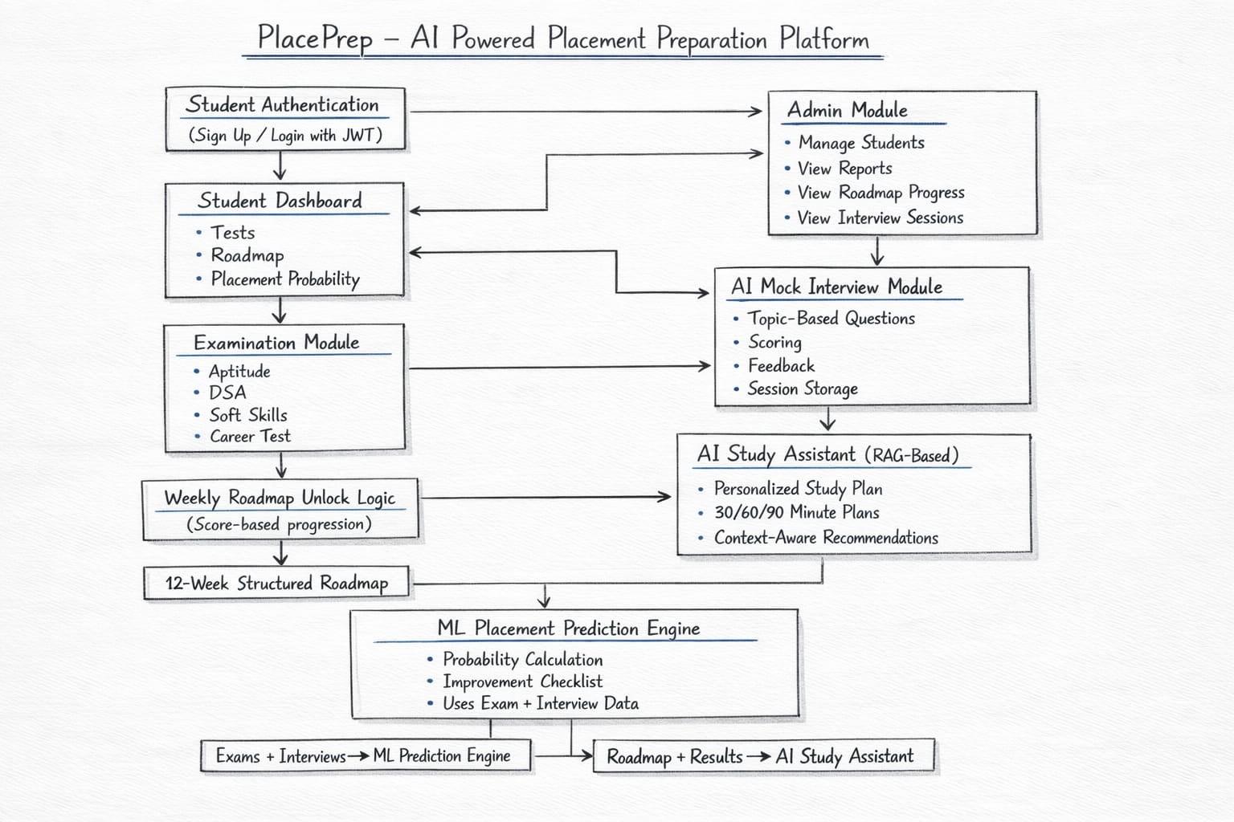

6. IMPLEMENTATION
The implementation of the Personalized Placement Assistance System is carried out using a modular approach. The system is divided into multiple functional modules to ensure scalability, flexibility, and ease of maintenance. Each module is responsible for a specific task in the overall workflow of the system.

6.1 MODULES DESCRIPTION

Step 1: User Authentication Module
- Users (students/admin) register and login using credentials
- Authentication is handled securely using backend validation
- User data is stored in the database
Function:
Ensures secure access and user identification

Step 2: Student Profile Module
- Students enter:
  - Academic details (CGPA, marks)
  - Technical skills (programming languages, tools)
  - Interests and career preferences
- Data is stored in MongoDB
Function:
Creates a complete student profile for analysis

Step 3: Placement Prediction Module
- Machine Learning models are applied:
  - Random Forest
  - Gradient Boosting
  - Naïve Bayes
- Predicts:
  - Placement probability
  - Job readiness score
Function:
Provides data-driven prediction of placement chances

Step 4: Career Recommendation Module
- Uses:
  - SBERT (semantic similarity)
  - Knowledge Graph (skill-job mapping)
- Suggests:
  - Suitable job roles
  - Required skills
Function:
Helps students choose the right career path

Step 5: Skill Gap Analysis Module
- Compares:
  - Student skills vs industry requirements
- Identifies:
  - Missing skills
  - Weak areas
Function:
Guides students on what to improve

Step 6: Interview Evaluation Module
- Students attend mock interviews
- Responses are analyzed using:
  - NLP techniques
  - Speech analysis
- Evaluates:
  - Communication
  - Confidence
  - Answer relevance
Function:
Improves interview performance through feedback

Step 7: Dashboard & Analytics Module
- Displays:
  - Placement prediction
  - Career recommendations
  - Performance progress
  - Skill improvement suggestions
Function:
Provides visual insights and tracking

Step 8: Admin Module
- Admin can:
  - Monitor student data
  - Analyze reports
  - Manage job roles and system data
- Generates analytics for placement tracking
Function:
Ensures system management and monitoring

6.2 TOOLS AND TECHNOLOGIES USED

Frontend
- React (Web Application)
- React Native (Mobile Application)

Backend

Node.js + Express.js

Database
- MongoDB Atlas (Cloud NoSQL database)

Machine Learning Libraries
- Scikit-learn
- TensorFlow
- Pandas, NumPy

Development Tools
- VS Code
- Git & GitHub
- Chrome Browser

6.3 IMPLEMENTATION

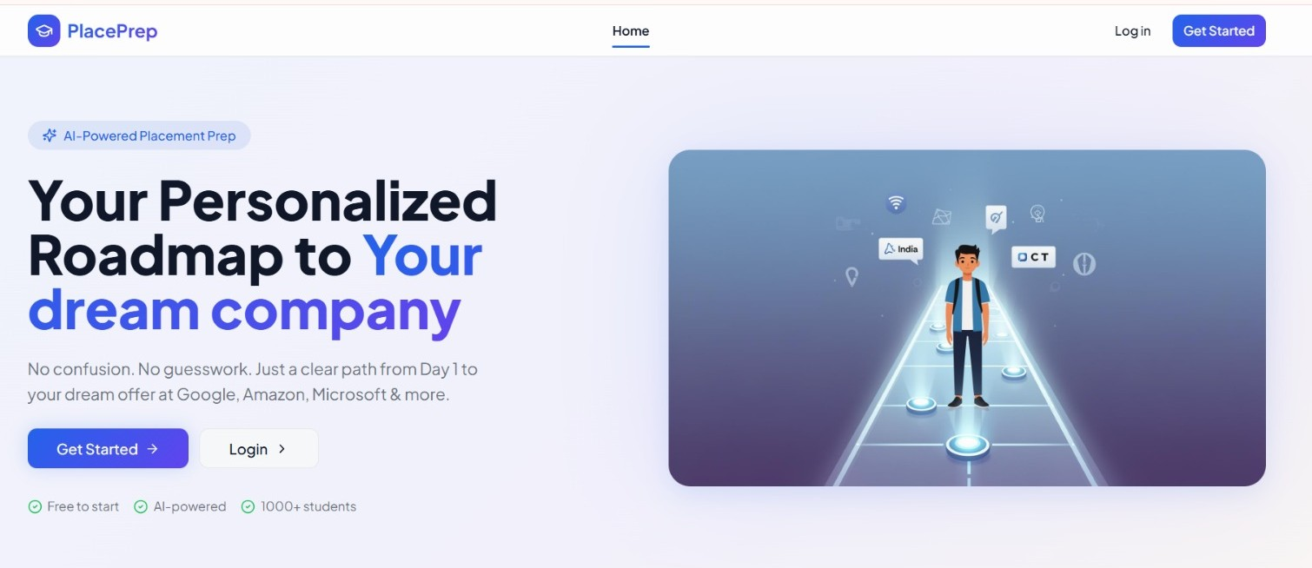

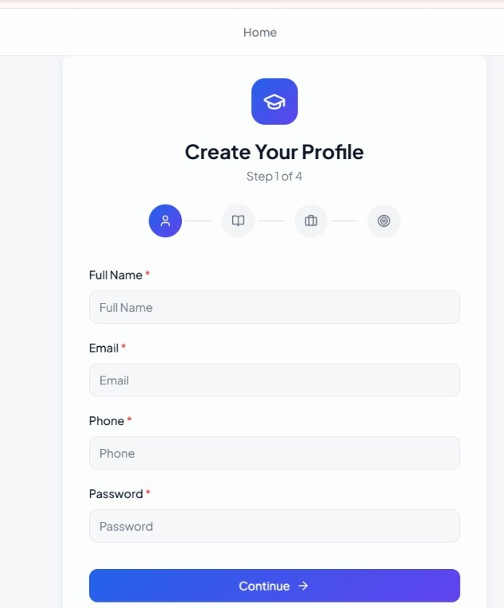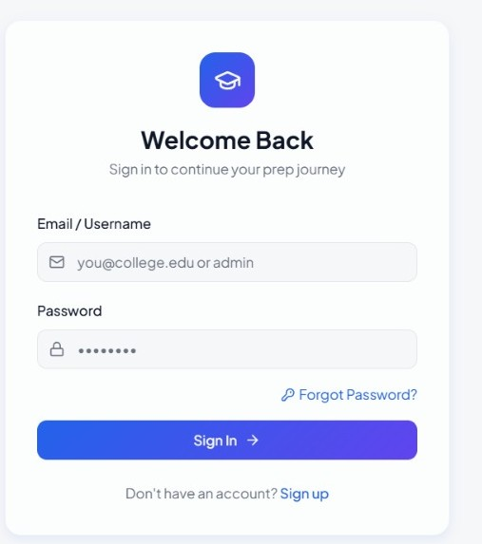

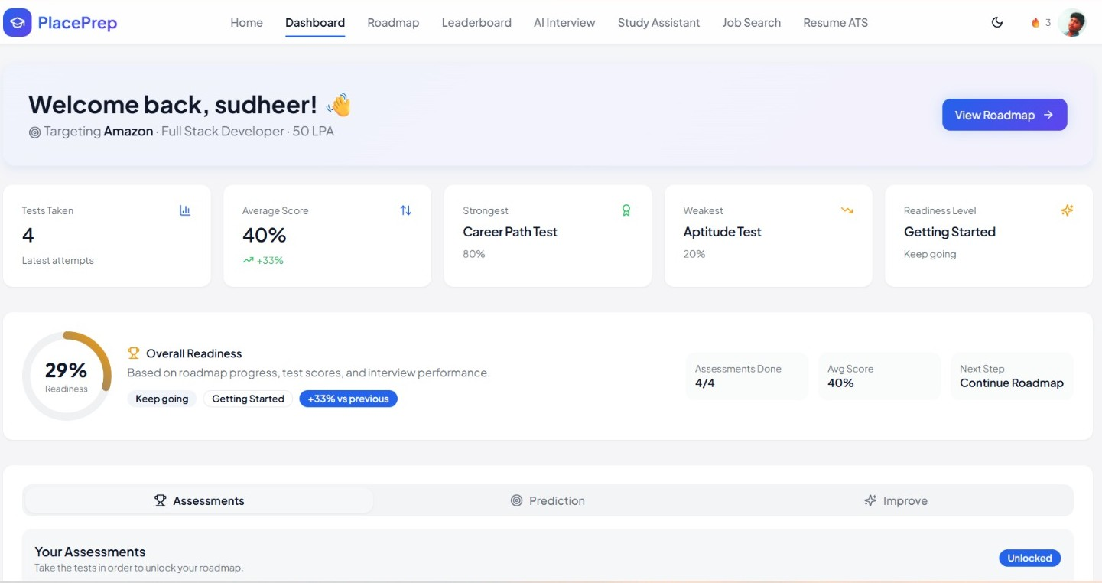

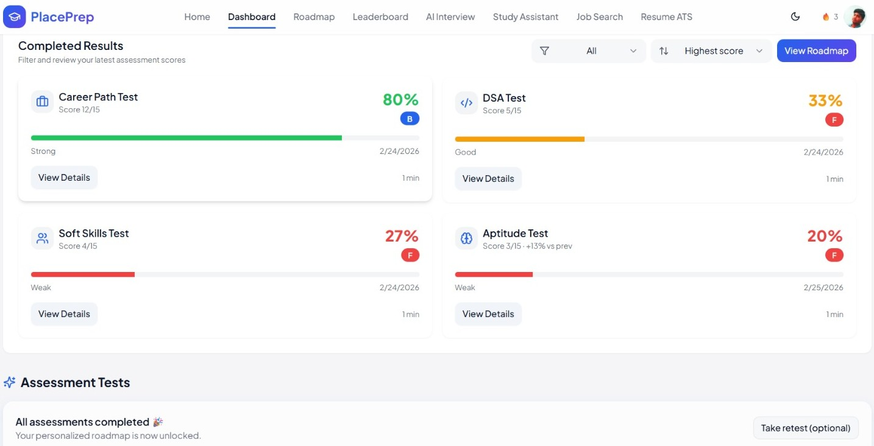

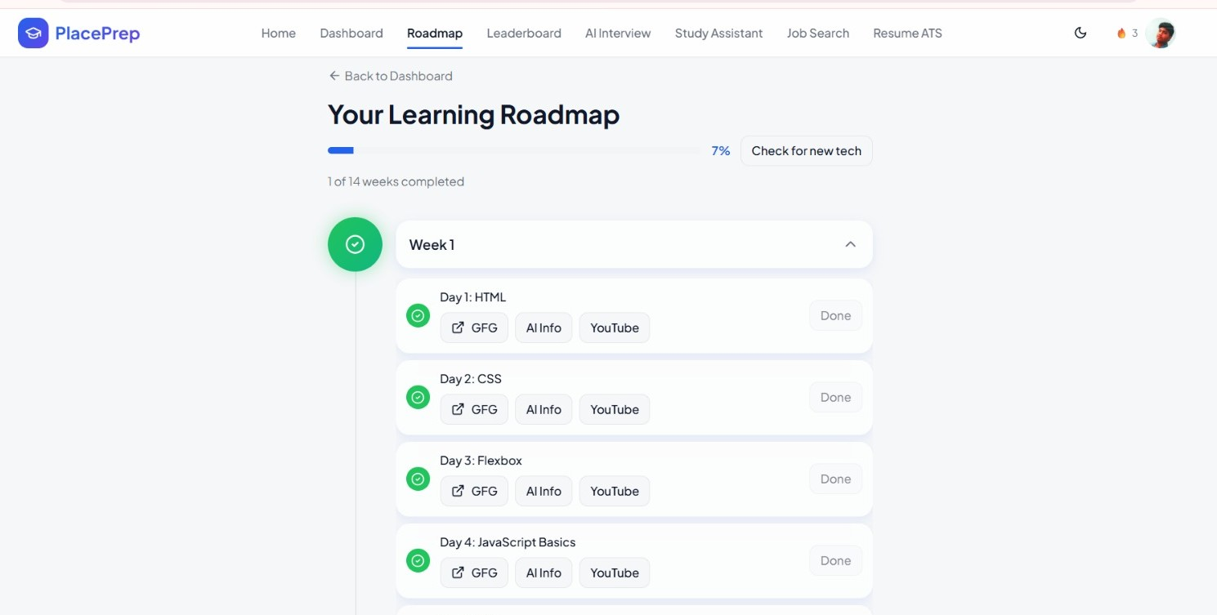

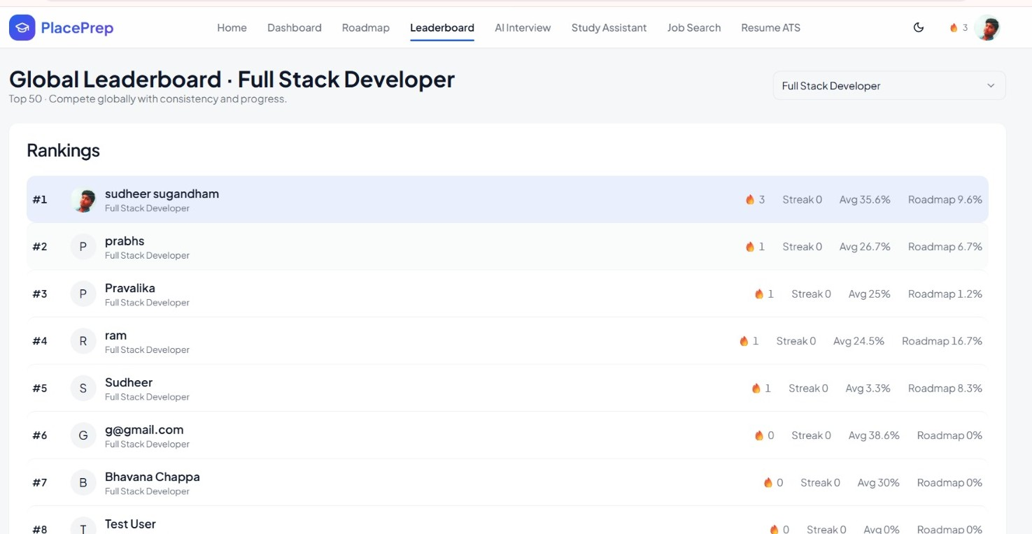

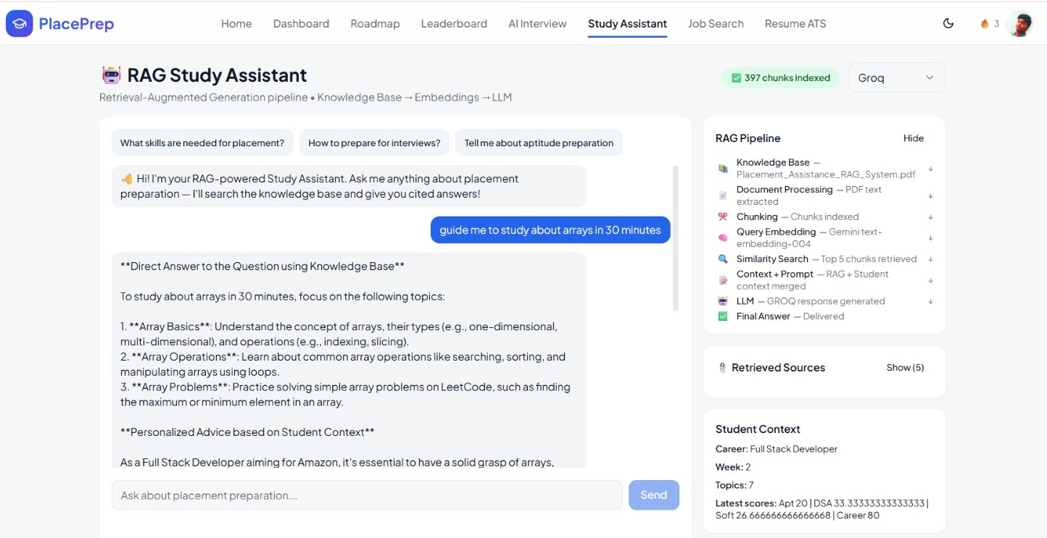

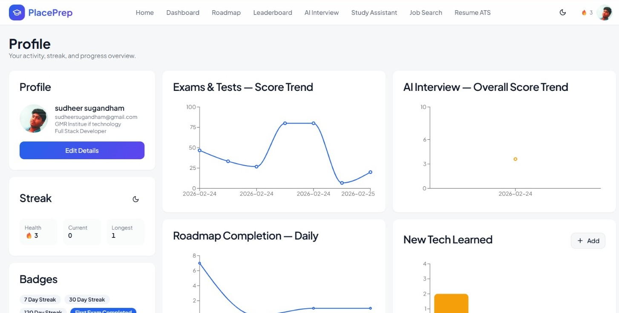

7. RESULTS & DISCUSSION
The proposed Personalized Placement Assistance System was successfully developed and tested to evaluate its effectiveness in improving student placement readiness and career guidance.
The system was tested using sample student data including academic performance, technical skills, and aptitude scores. The Machine Learning models such as Random Forest, Gradient Boosting, and Naïve Bayes were applied to predict placement probability. The results showed that the system was able to generate accurate and reliable predictions, helping students understand their chances of getting placed.
The career recommendation module provided personalized job role suggestions based on student profiles. By using semantic matching techniques such as SBERT, the system was able to identify relevant career paths aligned with user skills and interests. This helped students gain clarity about suitable career options.
The interview evaluation module using NLP techniques successfully analyzed user responses and provided feedback on communication skills, confidence, and answer quality. This feature proved highly useful in improving interview performance.
The skill gap analysis module identified missing or weak skills by comparing student profiles with industry requirements. Based on this analysis, the system provided actionable recommendations for improvement, enabling students to focus on specific areas.
The dashboard displayed all results including placement probability, recommended roles, performance metrics, and improvement suggestions in a clear and user-friendly manner. This allowed students to track their progress effectively.
Overall, the system demonstrated that integrating AI, Machine Learning, and NLP can significantly enhance placement preparation by providing personalized, data-driven insights.

DISCUSSION
The results clearly indicate that traditional placement systems can be significantly improved by incorporating intelligent technologies. The use of machine learning models improves prediction accuracy, while recommendation systems provide personalized guidance.
However, the system's performance depends on the quality and quantity of input data. Inaccurate or incomplete data may affect prediction results. Additionally, NLP-based interview evaluation may not fully capture human emotions and real-world interview dynamics.
Despite these limitations, the system provides a strong foundation for automated and intelligent placement assistance. With further improvements such as real-time data integration and advanced AI models, the system can become even more effective and reliable.

8. CONCLUSION
The proposed Personalized Placement Assistance System presents an innovative and effective solution to bridge the gap between academic learning and industry requirements. By integrating advanced technologies such as Machine Learning, Natural Language Processing, and Recommendation Systems, the platform provides intelligent and personalized guidance to students.
The system successfully predicts placement probability, recommends suitable career paths, evaluates interview performance, and identifies skill gaps. These features help students improve both technical and soft skills, ultimately enhancing their employability.
In addition, the system reduces manual effort for placement officers and provides a structured, data-driven approach to placement preparation. The user-friendly interface and real-time feedback mechanisms make it highly accessible and practical for students.
Although there are challenges such as data dependency and computational complexity, the overall benefits of the system outweigh these limitations.
In conclusion, the proposed system serves as a powerful tool for improving placement success rates and preparing students for real-world job opportunities. It represents a significant step toward the future of intelligent and automated career guidance systems.

9. FUTURE ENHANCEMENTS
The proposed Personalized Placement Assistance System provides a strong foundation for intelligent career guidance. However, there are several enhancements that can be implemented to further improve its functionality, scalability, and real-world applicability.

1. Real-Time Data Integration
The system can be enhanced by integrating real-time job market data from job portals such as LinkedIn, Naukri, and Indeed. This will help in providing up-to-date career recommendations based on current industry demands.

2. Advanced Deep Learning Models
More advanced deep learning models such as Transformer-based architectures (BERT, GPT) can be integrated to improve prediction accuracy and recommendation quality.

3. Multi-Language Support
The system can be extended to support multiple languages, enabling students from diverse backgrounds to use the platform effectively.

4. Mobile Application Deployment
A fully developed mobile application can be launched to improve accessibility and allow students to use the system anytime, anywhere.

5. Integration with College Placement Cells
The system can be integrated with college placement departments, allowing direct interaction between students, recruiters, and placement officers.

6. Advanced Interview Simulation
Future versions can include:
- AI-based video interview analysis
- Facial expression and emotion detection
- Real-time feedback during interviews

7. Personalized Learning Pathways
The system can provide structured learning roadmaps including:
- Courses
- Certifications
- Practice platforms
based on individual skill gaps.

8. Big Data and Cloud Integration
Using cloud computing and big data technologies, the system can handle large-scale data efficiently and support thousands of users simultaneously.

9. Industry Collaboration
Collaboration with companies can help in:
- Providing real-world datasets
- Improving prediction accuracy
- Offering direct placement opportunities

10. Gamification Features
Gamification elements such as:
- Points, badges, leaderboards
- Challenges and rewards
can be added to increase student engagement and motivation.

11.Neuro-Technology Integration
In future, the system can be enhanced by integrating Neuro-Technology (Brain-Computer Interface - BCI) to analyze students’ cognitive and emotional states during learning and interviews.
Using EEG-based sensors and neural signal processing, the system can:
- Monitor attention levels, focus, and stress during preparation
- Analyze emotional responses during mock interviews
- Provide real-time feedback based on brain activity
- Improve personalized learning paths based on cognitive patterns
- Enhance decision-making and career recommendations
This integration can significantly improve the accuracy of performance evaluation and create a next-generation intelligent placement system that understands both skills and mental readiness of students.

References

[1] S. Author et al., “Personalized process-type learning path recommendation based on process mining and deep knowledge tracing,” Knowledge-Based Systems, 2024.
[2] F. Author et al., “Job recommendation using bidirectional long short-term memory with attention mechanism,” IEEE Access, 2024.
[3] A. Author et al., “PathPilot: AI-based placement prediction and career recommendation system,” International Journal of Emerging Technologies, 2025.
[4] K. Author et al., “AI-driven competency recommendation using gradient boosting techniques,” Journal of Educational Data Mining, 2024.
[5] P. K. Arya et al., “AI job interview preparation portal,” International Research Journal of Modernization in Engineering Technology and Science (IRJMETS), vol. 7, no. 12, 2025.
[6] S. Sinchana et al., “Adaptive AI framework for streamlined placement preparation,” IJSART, vol. 11, no. 4, 2025.
[7] P. Nigam et al., “Placement Hive – Artificial intelligence based placement portal,” YMER, vol. 22, no. 4, 2023.
[8] H. Bisht et al., “Student placement prediction using classification techniques,” IJARSCT, vol. 3, no. 3, 2023.
[9] S. Author et al., “Placement prediction using machine learning algorithms,” IJRASET, vol. 10, no. 6, 2022.
[10] S. Author et al., “Soft skills assessment using machine learning and serious games,” Journal of Educational Technology Research, 2024.
[11] S. Author et al., “Ontology-based adaptive competency recommender system,” International Journal of Intelligent Systems, 2024.
[12] S. Author et al., “Student performance prediction using SVM and Naïve Bayes,” International Journal of Computer Applications, 2023.
[13] V. Balachandar and K. Venkatesh, “Multi-dimensional student performance prediction model (MSPP),” MethodsX, vol. 14, 2025.
[14] S. Author et al., “Systematic review of AI-based recommender systems using deep learning and hybrid models,” IEEE Access, 2024.
[15] S. Author et al., “Process mining-based adaptive learning pathway recommendation system,” International Conference on Machine Learning and Automation, 2024.
[16] S. Author et al., “Multi-source intelligent tutoring system for personalized learner modeling,” IEEE Access, 2025.

